

Portal Upload Writer Service

Project Implementation

Integration Kit Design

# Table of Contents

Table of Contents 2

Overview 3

Design 4

Implementation 4

Request 4

Response 4

Configuration 5

Persistence 5

Presentation 5

Logic 6

Extensions 8

Configuration 8

# Overview

As part of the Turnstile Kit a new service will be added to AgencyPortal. This service can be seen highlighted in yellow in Figure 1.



Figure 1

# Design

The primary responsibility of this service is to take in ACORD XML and create a work item. The end result will be a new work item record stored in the database. The service response will contain a URL to the new work item.

# Implementation

## Request

The HTTP request is a simple text message containing XML. The XSD structure is shown below:

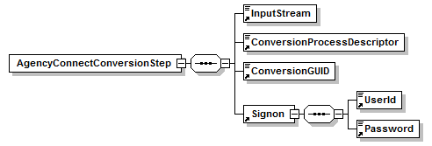

## Response

The HTTP response is a simple text response containing XML. The XSD structure is shown below:

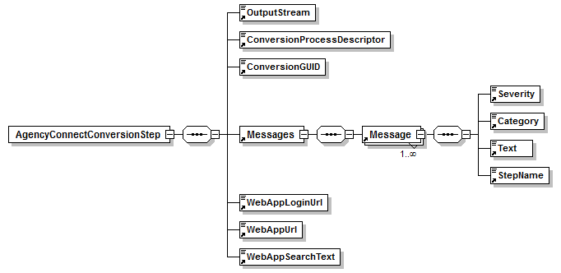

## Configuration

A new servlet will be added and configured in web.xml:

<servlet>

<description>Creates Work Items</description>

<display-name>Upload Writer</display-name>

<servlet-name>UploadWriterServlet</servlet-name>

<servlet-class>com.agencyport.shared.upload.CommonUploadWriter</servlet-class>

</servlet>

<servlet-mapping>

<servlet-name>UploadWriterServlet</servlet-name>

<url-pattern>/UploadWriter</url-pattern>

</servlet-mapping>

## Persistence

The servlets duties are to store the ACORD XML into the database. The XMLSTORE table contains a blob of XML and the WORK_ITEM stores meta-data about the work item.

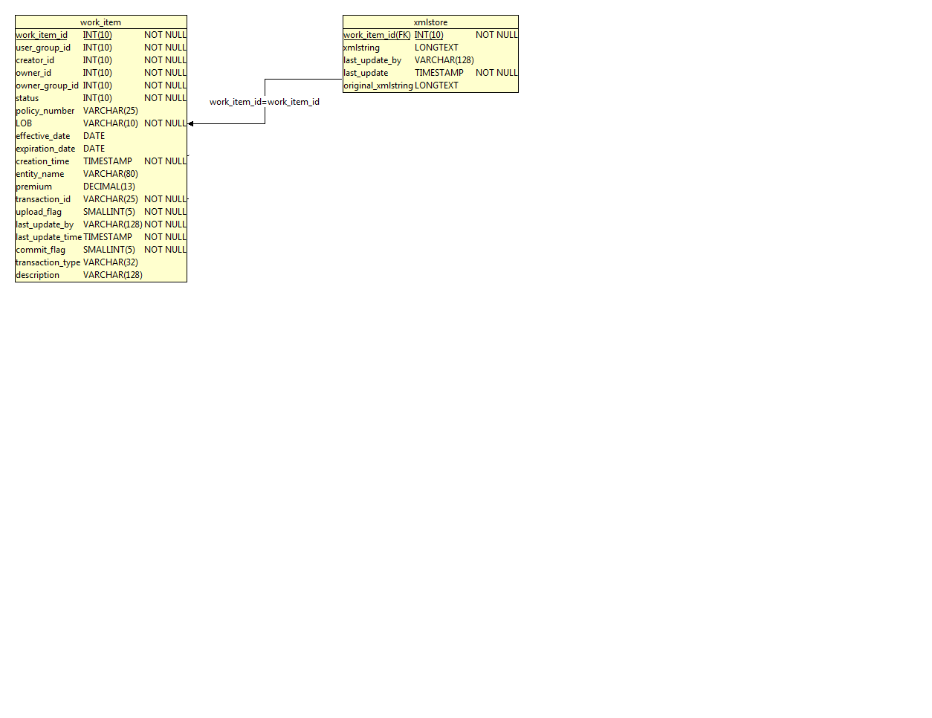

## Presentation

When the user navigates to the URL above they will be presented with the following pop-up:

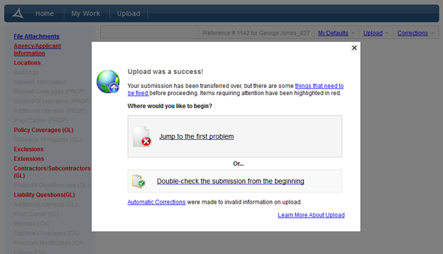

## Logic

The sequence diagram below shows the important steps in a work item creation:

1. Establish a Security Profile
2. Transform to Simplified ACORD
3. Determine the Transaction Definition
4. Alter data before Upload Manager
5. Invoke Upload Manager
   1. Creates Transaction Validation Report
   2. Creates Transaction Correction Report
6. Alter data after Upload Manager
7. Transform back to Standard ACORD
8. Persist XML
   1. Create Work Item
   2. Adjust Work Item Menu
9. Write Response

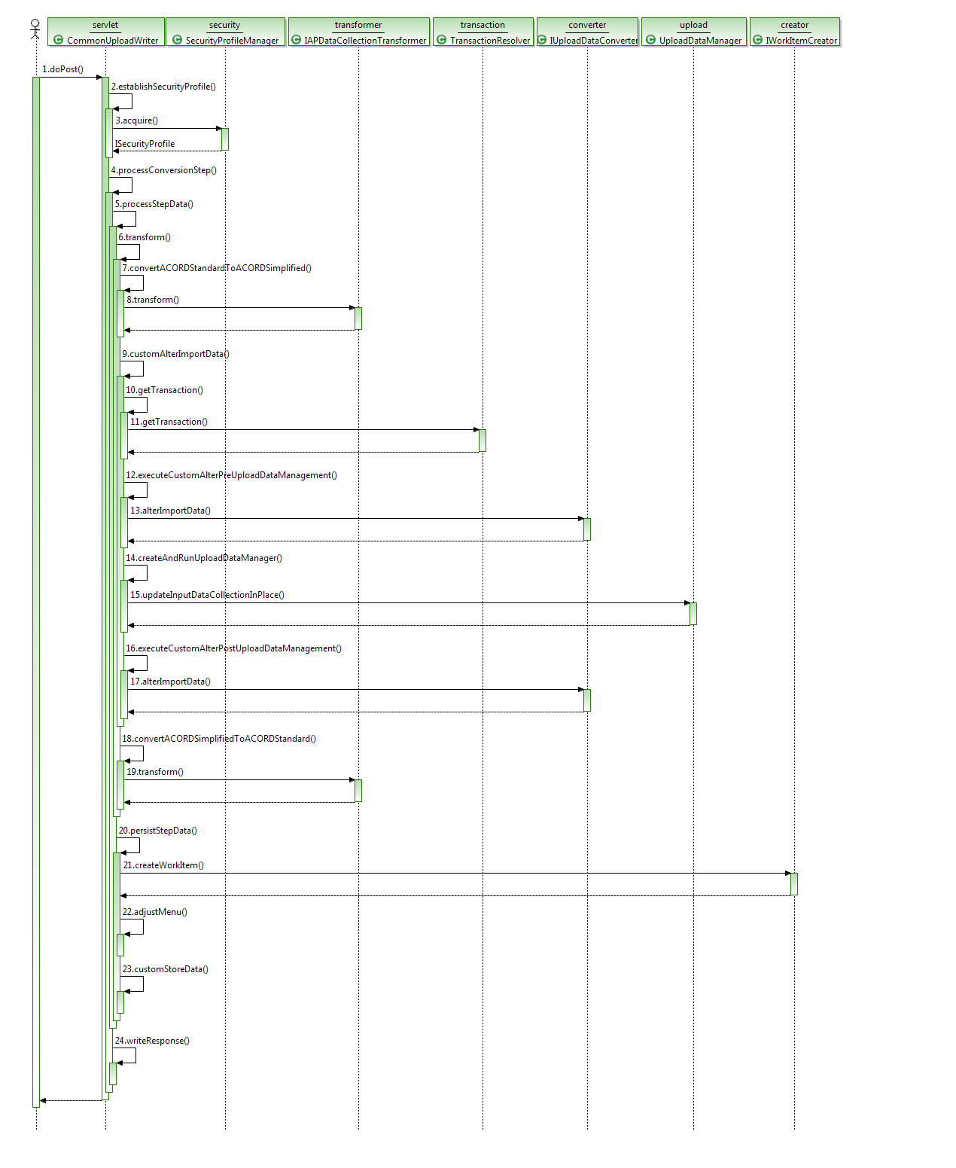

## Extensions

There are several opportunities to override the base class your own implementation:

* **SecurityProfileManager** can be extended and overridden using the global property:

security.profile_manager_classname

* **IAPDataCollectionTransformer** can be implemented and registered in the product database.

<artifact type="transformer" resourceId="*.xml"/>

* **TransactionResolver** can be overridden using the global property:

upload_transaction_resolver_class_name

* **UploadDataManager** can be overridden using the transaction level property:

upload_data_manager_class_name

* **IUploadDataConverter** can be implemented using the transaction level property:

upload_data_converter_class_name

* **IWorkItemCreator** can be implemented using the transaction level property:

workitem.creator_classname

* **CommonUploadWriter** can be extended and registered in web.xml:

<servlet-class>*.CustomUploadWriter</servlet-class>

## Configuration

The default implementation supports the following properties.

|  |  |  |
| --- | --- | --- |
| **Property** | **Default** | **Description** |
| should_retain_id_attributes | false | Controls whether or not ID Retention should be engaged |
| should_show_immediately_on_worklist | true | Controls whether an uploaded work item shows on worklist by default. |
| should_support_return_url | true | Controls whether a URL to the work item should be returned. |
| should_run_data_corrections | true | Controls whether the corrections officer should be engaged. |
| should_persist_workitem | true | Controls whether the work item should be persisted. |
| should_remove_file_attachments | true | Controls whether file attachment aggregates should be removed. |